**File Download**

<https://github.com/diioradhitya/Hadoop.2.7.2/releases/tag/v1.0>

**Set up**

1. Check either Java 1.8.0 is already installed on your system or not, use **"Javac -version"** to check.

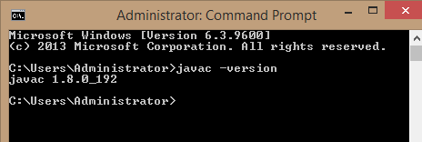

1. If Java is not installed on your system then first install java under **"C:\work\Java"**

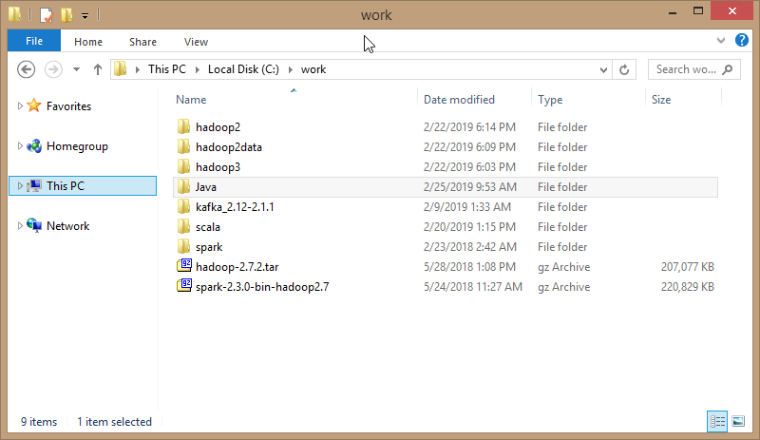

1. Extract file hadoop 2.7.2.tar.gz or hadoop-2.7.2.zip and place under **"C:\work\hadoop2"**.

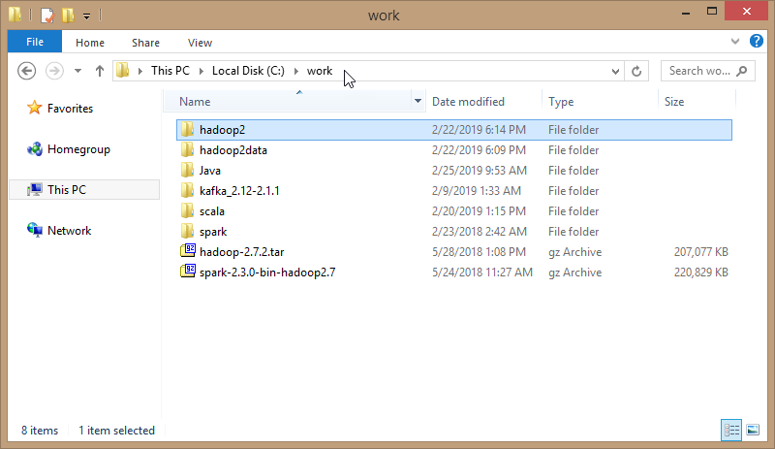

1. Set the path HADOOP_HOME Environment variable on windows (see Step 1,2,3 and 4 below).

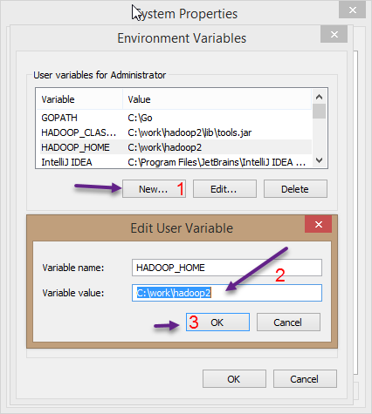

1. Set the path JAVA_HOME Environment variable on windows (see Step 1,2,3 and 4 below).

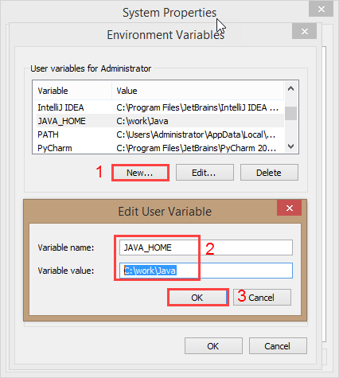

1. Next we set the Hadoop bin directory path and JAVA bin directory path.

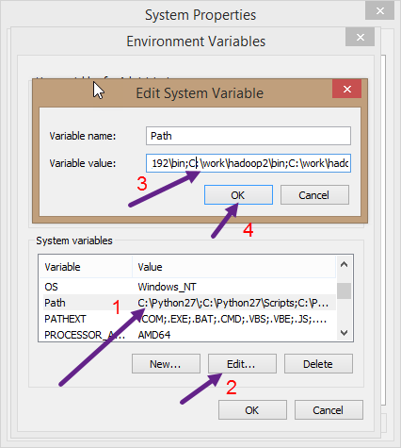

**Configuration**

1. Edit file **C:/work/hadoop2/etc/hadoop/core-site.xml**, paste below xml paragraph and save this file.

<configuration>

<property>

<name>fs.defaultFS</name>

<value>hdfs://localhost:9000</value>

</property>

</configuration>

1. Rename "mapred-site.xml.template" to "mapred-site.xml" and edit this file **C:/work/hadoop2/etc/hadoop/mapred-site.xml**, paste below xml paragraph and save this file.

<configuration>

<property>

<name>mapreduce.framework.name</name>

<value>yarn</value>

</property>

</configuration>

1. Create folder **"data"** under **" C:/work/hadoop2"**

* Create folder **"datanode"** under **" C:/work/hadoop2/data"**
* Create folder **"namenode"** under **" C:/work/hadoop2/data"** 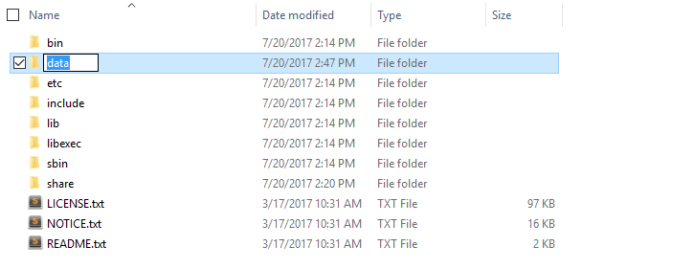

1. Edit file **C:/work/hadoop2/etc/hadoop/hdfs-site.xml**, paste below xml paragraph and save this file.

<configuration>

<property>

<name>dfs.replication</name>

<value>1</value>

</property>

<property>

<name>dfs.namenode.name.dir</name>

<value>C:\work\hadoop2\data\namenode</value>

</property>

<property>

<name>dfs.datanode.data.dir</name>

<value>C:\work\hadoop2\data\datanode</value>

</property>

</configuration>

1. Edit file **C:/work/hadoop2/etc/hadoop/yarn-site.xml**, paste below xml paragraph and save this file.

<configuration>

<property>

<name>yarn.nodemanager.aux-services</name>

<value>mapreduce_shuffle</value>

</property>

<property>

<name>yarn.nodemanager.auxservices.mapreduce.shuffle.class</name>

<value>org.apache.hadoop.mapred.ShuffleHandler</value>

</property>

</configuration>

1. Edit file **C:/work/hadoop2/etc/hadoop/hadoop-env.cmd** by closing the command line**"JAVA_HOME=%JAVA_HOME%"** instead of set **"JAVA_HOME=C:\work\Java"** (On C:\work\Java this is path to file jdk.18.0)

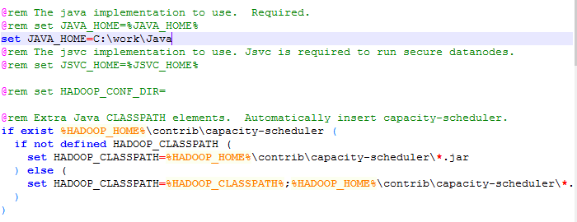

**Hadoop Configuration**

1. Dowload file hadoop2.7.2-configuration.zip (Link: <https://github.com/diioradhitya/Hadoop.2.7.2/blob/master/hadoop2.7.2-configuration.zip>)
2. Delete file bin on C:\work\hadoop2\bin, replaced by file bin on file just download (from hadoop2.7.2-configuration.zip).
3. Delete file etc on C:\work\hadoop2\etc, replaced by file etc on file just download (from hadoop2.7.2-configuration.zip).
4. Open cmd and typing command **"hdfs namenode –format"** . You will see

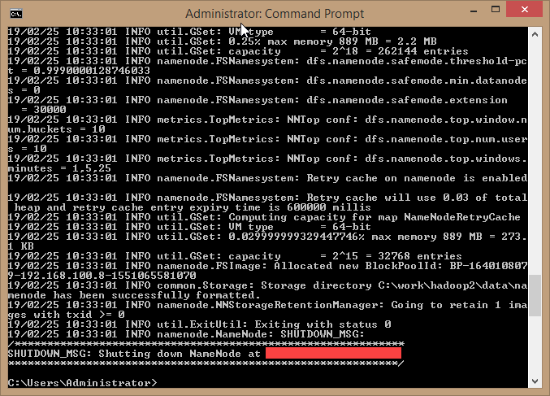

**Testing**

1. Open cmd and change directory to "C:\work\hadoop2\sbin" and type **"start-all.cmd"** to start apache. 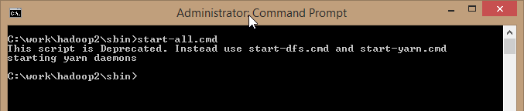
2. Make sure these apps are running

* Hadoop Namenode
* Hadoop datanode
* YARN Resourc Manager
* YARN Node Manager

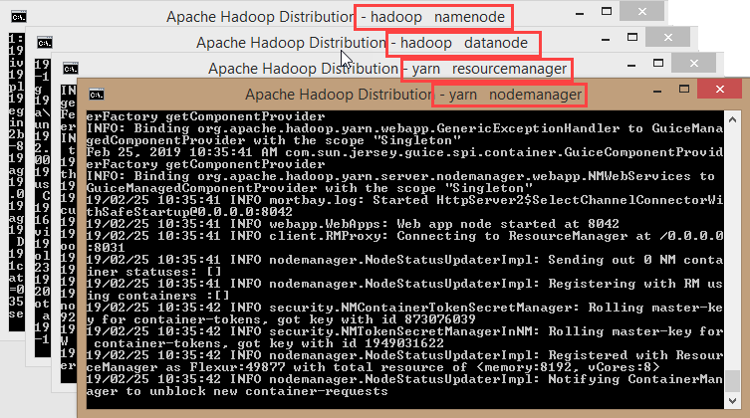

1. Open: [http://localhost:8088](http://localhost:8088/)

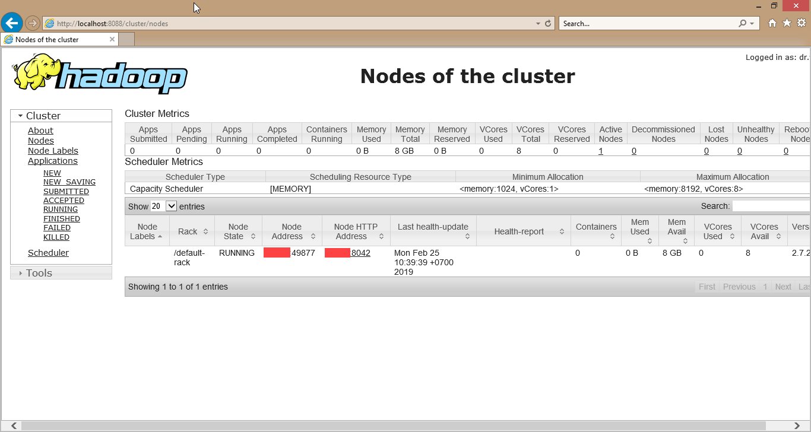

1. Open: [http://localhost:50070](http://localhost:50070/)

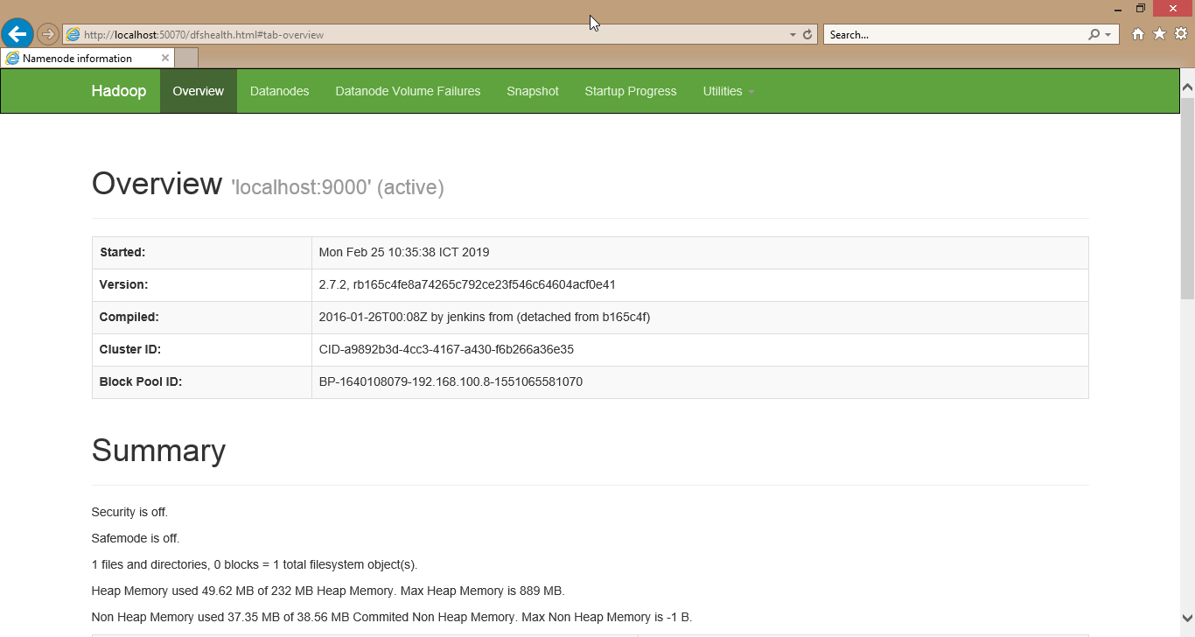

Congratulations, Hadoop installed.